East Clandon Village Hall
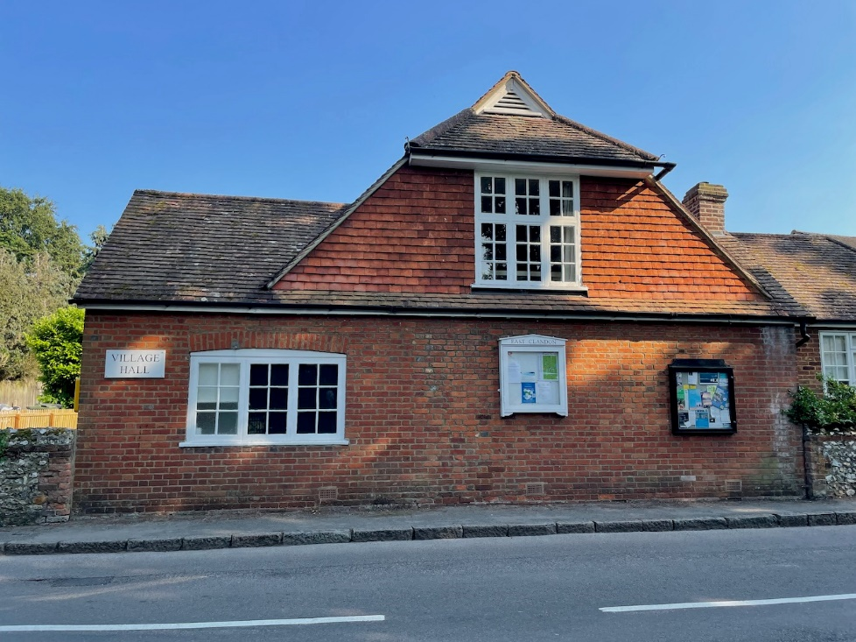
East Clandon Village Hall was built in 1920 by the architect HS Goodhart-Rendel who was the owner of Hatchlands Park, now a National Trust property.
There is no gas supply in the village and the Hall relies on an old oil-fired boiler for heating so the Trustees realised that they urgently needed to explore the best options to maintain the facility for the villagers into the future but reduce energy use and so save money and reduce the carbon footprint.
With the help of an energy audit (carried out under the Emphasis 3 CO2 Reductions Programme) which identified areas where improvements and savings could be made it was decided to initially concentrate on simple measures like draught proofing and upgrading the roof insulation, but also consider wall insulation and the installation of solar panels.
Solar panels and their possible funding are being actively investigated, but the Audit revealed that approximately 50% of the external walls had a cavity which was suitable for filling with the appropriate insulation and so it was decided to pursue this, and quotations were sought from certified installers.
With this information the Trustees were able to apply for a Grant from Surrey Climate Commission, and we were delighted that our application was successful and so were able to appoint a contractor who has now completed the work.

