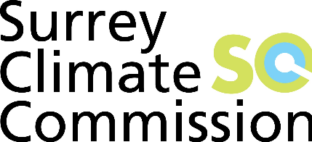

UK Commissions Zoom Conference
On the 10th June all the existing and prospective commissions from around the UK met up by zoom link. The aim was to discuss the way forward and see how we can collaborate to accelerate the process of decarbonisation in the Country. It was also very reassuring that so many cities and larger towns were singing from the same song sheet.
Significantly we are, at present, the only County to have set up a commission, and again it was reassuring to see far we had come compared with many of our peers. The impression was given that Surrey could be seen very much as a pilot for other counties to follow.
After hearing about the progress of each commission the agenda focussed on how we can help each other and collaborate as a unified force to be a valuable influence on Government. In particular we felt that we should be communicating with Government to emphasise that any recovery, in the wake of COVID, must be the right recovery in line with zero carbon commitments.
There was also a strong feeling that the recovery should also be expressed in terms of economic opportunities, and, in particular, new jobs. In addition, it was agreed that it should be a fair recovery, which provides opportunity for all, especially in those more deprived areas of the UK.
Andy Gouldson, the Chair of the Leeds Commission, who was leading the meeting, said he would look to request contributions from the various commissions and then make a request to central Government.
There was also consensus that we should all contribute to an exchange of information and best practice, and it was suggested that some sort of data base be set up. A.G., for example, mentioned the at Leeds produce Position Papers, which provide detailed information on the current state of development and policy in particular sectors.
Finally, it was agreed that future meets should be organised on a quarterly basis.

Richard Essex
Chair of Surrey Climate Commission

