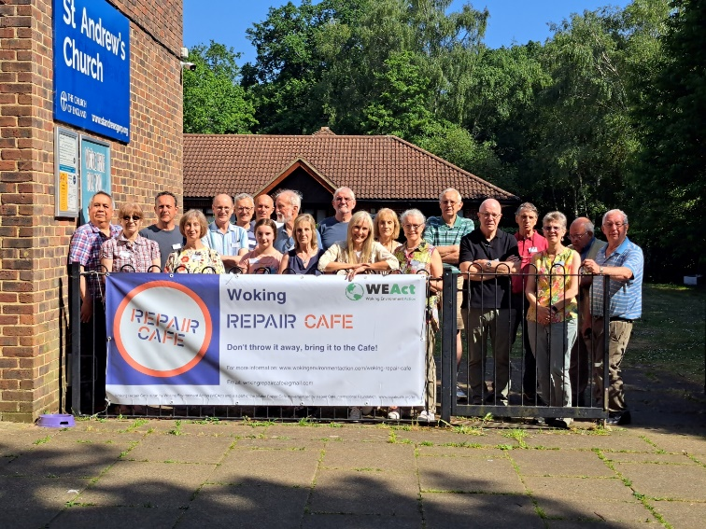
The Woking Repair Cafe held its first event on Saturday 10th June at St Andrew’s Church in Goldsworth Park. We had 40 visitors, and feedback from both visitors and volunteers was extremely positive, and everyone enjoyed the day.

The event was the culmination of months of planning. Back in January Woking Borough Council asked Woking Environment Action (WEAct) if we would be interested in starting a repair cafe in Woking. This sounded like a good idea so in February we went to visit the well-established Farnham Repair Cafe, run by Martin Charter and his team. After operating for 14 years they had a huge amount of experience to share with us. We thought that the atmosphere was wonderful, the products being repaired eclectic, and it was a great match for the vision and values of WEAct. Repairing and saving items from the bin is right up our street!
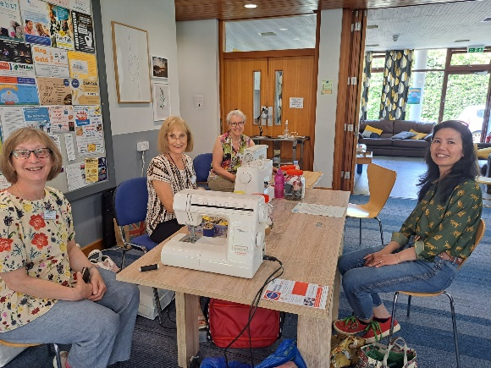
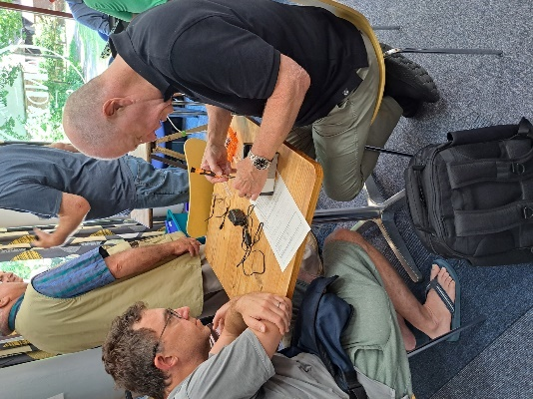
After a very excited train ride home we decided that was just what Woking needed so we started working on recruiting volunteer fixers and a front desk team. We advertised (for free) on local social media pages and had an article published in Woking News and Mail. We also contacted our own personal networks of friends and neighbours. We soon started to get a wide range of volunteer applications, which gave us confidence that we could get a Woking Repair Cafe up and running. Our volunteers have such great skills and are riotously enthusiastic. We decided to aim for a mid-June start, to organise our planned ways of working as well as to coincide with Great Big Green Week (a key week in the WEAct calendar).
Our next steps involved sorting out insurance and looking for a venue. We started off thinking we would run all our cafes in the town centre, but we quickly got volunteer feedback that we would be more accessible for people if we ran in a number of neighbourhood areas of Woking. St Andrew’s Church contacted us to say they had been thinking of starting their own Repair Cafe, so we teamed up with them as our first venue. Then other Woking churches contacted us, and we are now planning to rotate round four different venues across Woking. A roving Cafe like this is less common but we’re certainly going to trial this approach.
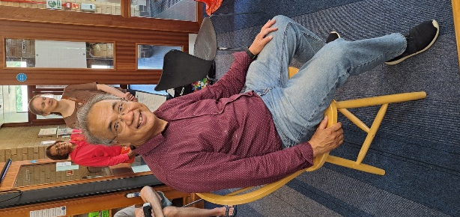
Surrey Climate Commission launched a grant programme for sustainability projects and in March we were delighted to be awarded funds to pay for our PAT tester, some of our technical equipment and a lovely banner (see our fabulous Cafe team photo).
Throughout March and April we spoke to several other Repair Cafes and borrowed their documentation to help us sort out our own processes, forms, and risk assessments. We ran Zoom orientation briefing sessions for all our volunteers and sorted out what tools and resources we would need. We also signed up with the International Repair Cafe Organisation and found their resources extremely helpful. https://www.repaircafe.org/en/
Publicity for the event was done exactly as per our volunteer recruitment drive using (free) social media, physical posters (which we put up all over the place) and word of mouth. It was nerve-wracking to know how much to do, as we wanted to be busy but not to have lots of people disappointed that they couldn’t get in. On all our publicity we asked visitors to email us with what they were planning to bring. This worked well for us as by Cafe eve we had 32 enquiries.
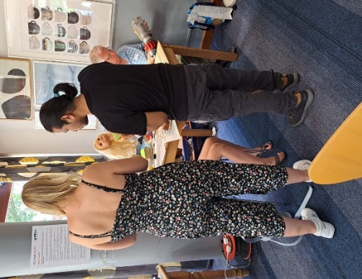
At last, it was the 10th June, the weather was glorious, and we had a fantastic day. Our 40 visitors arrived in a steady flow and our volunteer fixers enjoyed the challenge of trying to fix various items including:
- Toys: getting an arm back on to a doll, a toy helicopter with a broken rotor blade
- Electrical items: broken vacuum cleaners, lamps, a CD player, a radio, a toaster, a hairdryer, 2 coffee grinders
- Furniture: a broken chair and a coffee table
- Textiles: various clothing repairs, a replacement zip, a handbag strap, and a sandal
Our fixers fixed, gave advice and kindly agreed to take a few items home to finish off. Some items were declared unrepairable, often because they were glued up so strongly that we just couldn’t get into them!
Initial data suggests that we fixed, partially fixed, or gave advice on 85% of items, 15% were unrepairable. We avoided 35.4 kg of items going into the waste system which we’re delighted with.
For the time being at least, our Repair Cafes will run on the 2nd Saturday of the month from 10am to 1pm, doors close to new arrivals at 12.30pm. We’re going to continue to ask visitors to let us know what they’ll be bringing by emailing wokingrepaircafe@gmail.com as this worked so well for us in June.
Next events:
Saturday 8th July | St Michael’s Church Sheerwater | GU22 5PJ
Saturday 12th August | St Mark’s Church, Westfield | GU22 9QA
Saturday 9th September | Trinity Methodist, Town Centre | GU21 4LH
Saturday 14th October | St Andrew’s Church, Goldsworth Park | GU21 3LG
Thanks to these churches for their support!
More information is available at https://wokingenvironmentaction.com/woking-repair-cafe/

