Walton Allotment Association – gutter and water butt project
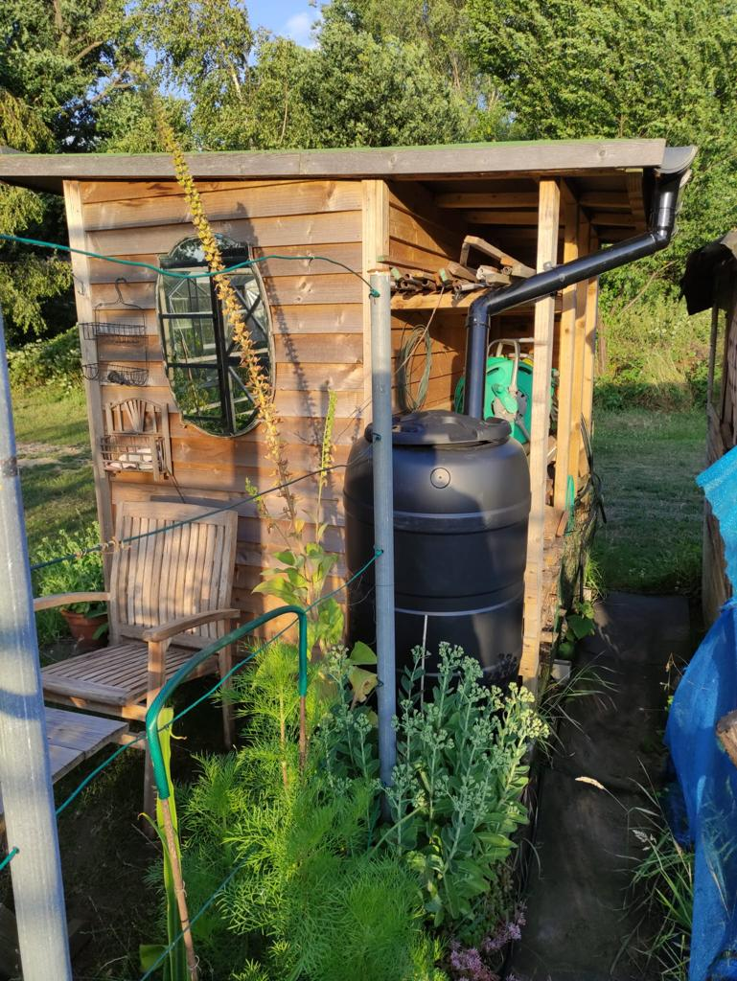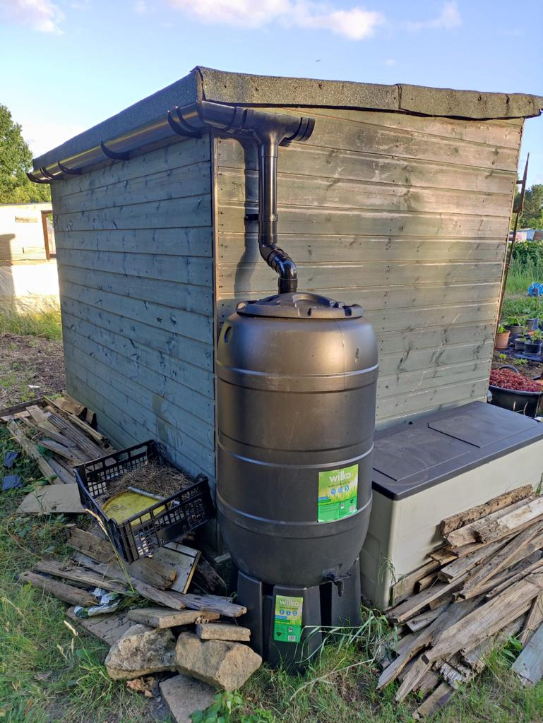
Walton Charity has 4 allotment sites and with the help of Walton Allotment Association manage around 400 tenants. The charities are taking proactive steps to encourage water conservation and sustainable practices among allotment tenants. The initiative to install water butts and sheds with guttering is a positive step towards utilising rainwater runoff and reducing reliance on tap water.
Conserving water is crucial, especially during dry summer months when water demand tends to increase. By promoting the use of rainwater collected in water butts, tenants can reduce their reliance on tap water and contribute to water conservation efforts. Additionally, using rainwater is beneficial for plants as it tends to be less alkaline compared to tap water.
The installation of water butts has also addressed the issue of multiple plots sharing a single tap. With more tenants having access to their own collected rainwater, it frees up the shared tap for other tenants to use tap water when necessary. This improves overall efficiency and allows for better allocation of water resources.
The financial support from the Surrey Climate Commission's Community Grants for Sustainability program has enabled the installation of guttering and water butts on an additional /26 sheds. This funding has significantly expanded the scope of the initiative, allowing for greater water conservation efforts across the four allotment sites in Walton on Thames and Hersham.
The positive impacts and benefits of this initiative, such as reduced water bills for the Charity and the improved water management for tenants, are likely to inspire more tenants to adopt the practice of collecting rainwater in their own gardens. By observing the benefits experienced by their plot neighbours, other tenants may be motivated to install water butts and contribute to sustainable water conservation efforts.
Furthermore, the presence of a community allotment and the involvement of volunteers and local school children provide an excellent opportunity to educate and raise awareness about sustainable water conservation. By showcasing the benefits of rainwater collection and highlighting the importance of water conservation, the initiative can inspire not only the tenants but also the wider community to adopt sustainable practices in their own gardens.
Walton Charity and Walton Allotment Association hope that promoting water conservation through the installation of water butts and sheds, along with the associated educational activities will contribute to a more sustainable and environmentally friendly approach to food production while addressing the increasing challenges of water scarcity during dry seasons.

